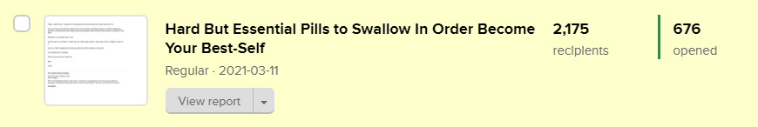
676 people opened this email: https://preview.mailerlite.com/o0w3a6

-------------------------------------------------------------

Hard But Essential Pills to Swallow In Order Become Your Best-Self

Xyz,

Ambitious people are common.

That gateman you think looks like he’s empty probably even has more ambition than you ever know. But I have come to realise that most of us doubt ourselves. All of us in some shape or form are stuck in wonderland.

One of the most difficult yet useful skills is the ability to balance having optimism about your future & looking at your environment, and your circumstances without sugar-coated glasses.

In my experience, taking the discomfort upfront can feel horrible in the short run but rewarding in the long run. Just like hitting the gym early in the year to get that summer body or like taking a course to improve your business skills to keep customers coming through the door.

Pushing the hard things away gives comfort in the short term, but it always comes back to haunt you.

Take a look at the truths I’m about to share with you. You’re free to disagree with them. Before you do, take a look at yourself and your situation honestly to determine if it’s true, or you’re just hiding.

Have you ever felt like the universe is working against you?

Just when you’ve improved your finances, your car breaks down. You wake up on the wrong side of the bed and your hand hurts for weeks, come to work to a nagging boss and go home to a cheating spouse.

It’s like for every step you take forward, you take three back. Just as you’re making headway, something or someone knocks you down.

If only life would give you a break, you tell yourself, you’d have enough energy to make an effort to become successful.

In fact, when you push to do something outside of the box — start a business, write a book, tell stories, carve your own route — not only will things get worse before they get better, you’ll still have to work to maintain what you’ve achieved.

The StoryWriting Bootcamp is almost here. I will teach you everything you need to know about delivering captivating, compelling and persuasive stories for your book and business.

Lamide Johnson.

Xyz,

Today, I will be brief - maybe this is perhaps the shortest email you’d have read from me.

You see, there is this task you need to do, but you keep on pushing it away. It could be writing that proposal, sending that email, designing that slides, launching that product, working on that book.

Whatever it is, go get it done, now.

I did not ask you to finish it - well if you can, that’s great: all I need you to do is to begin to work on it.

As you finish reading this email, go ahead and start working on that task.

The hardest part is starting.

Tell me once you start. Write me.

Best,

Lams!

